**National University of Computer & Emerging Sciences, Peshawar**

**School of Computing Department**

**Spring 2025, Lab Manual – 08 Task**

|  |  |
| --- | --- |
| **Course Code: CL-2005** | **Course : Database Systems Lab** |
| **Instructor(s) :** | **Yasir Arfat.** |

**Task-01**

Perform the lab manual example as first Task

**Task-02**

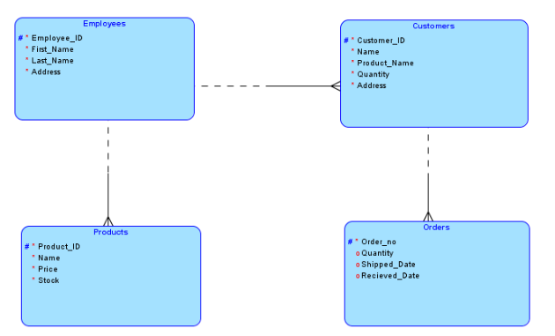

* Create a physical design (DDL) from the above logically designed database.
* Keeping in mind the logical design, create foreign keys in each table where required.
* Populate each table up to maximum three records.

**Task-03**

This system is designed to streamline various hospital functions, including patient management, appointment scheduling, and electronic health record (EHR) management. That consists of following classes:

1. **Patient:** 
   * PatientID (Primary Key) , First Name , Last Name ,Date of Birth, Gender ,Contact Number and Address
2. **Doctor:**
   * DoctorID (Primary Key) ,First Name, Last Name ,Specialization, Contact Number and Email
3. **Appointment:**
   * AppointmentID (Primary Key) ,Appointment Date and Time and Status (Scheduled, Completed, Canceled)
4. **Medical Record:**
   * RecordID (Primary Key) ,Date ,Diagnosis ,Treatment and Medications
5. **Billing:**
   * BillingID (Primary Key) ,Date ,Total Amount and Payment Status (Paid, Pending)

# Relationships:

* Patients can have multiple appointments, medical records, and bills.
* Doctors can have multiple appointments, medical records, and bills.
* Appointments are associated with one patient and one doctor.
* Medical records are associated with one patient and one doctor.
* Bills are associated with one patient, one doctor, and one appointment.

# Tasks to do:

1. Develop the Logical Model Diagram for the EHR database and build the design using a data modeling tool data modeler
2. Develop the Relational Model Diagram for the EHR database and build the design using a data modeling tool data modeler (create foreign keys in each table where required.)
3. Generate DDL

**Task-04**

Design a database to manage employees, departments, projects, attendance, and payroll.

**Schema Overview**

* **Employee (EmployeeID, Name, DOB, Contact, Email (Unique, Not Null), HireDate, DepartmentID (FK))**
* **Department (DepartmentID, Name, Location, ManagerID (FK))**
* **Project (ProjectID, Name, StartDate, EndDate, Status)**
* **Employee_Project (EmpProjectID, EmployeeID (FK), ProjectID (FK), Role)**
* **Attendance (AttendanceID, EmployeeID (FK), Date, Status)**
* **Payroll (PayrollID, EmployeeID (FK), Salary, Bonus, Deductions, NetSalary)**

**Relationships**

* Each employee belongs to **one** department but can work on **multiple** projects.
* Each department has **one manager (an employee)**.
* Projects involve **multiple employees** with assigned roles.
* Attendance is **recorded daily** for all employees.
* Payroll is **processed for each employee**.

**Tasks**

1. **Logical Model:** Create a **Logical Model Diagram**.
2. **Relational Model:** Design a **Relational Model** with foreign keys.
3. **DDL Script:** Generate **SQL DDL** to define the schema.
4. **Constraints:** Ensure **Email is Unique & Not Null**, enforce data integrity.

**Task-05**

Consider a  [NCRA-NATIONAL CENTER OF ROBOTICS & AUTOMATION Camera-Ready Paper Submission System](https://ncai.smme.nust.edu.pk/)

CONFERENCE_REVIEW database in which researchers submit their research papers for consideration. Reviews by reviewers are recorded for use in the paper selection process. The database system caters primarily to reviewers who record answers to evaluation questions for each paper they review and make recommendations regarding whether to accept or reject the paper. The data requirements are summarized as follows:

* Authors of papers are uniquely identified by e-mail id. First and last names are also recorded.
* Each paper is assigned a unique identifier by the system and is described by a title, abstract, and the name of the electronic file containing the paper.
* A paper may have multiple authors, but one of the authors is designated as the contact author.
* Reviewers of papers are uniquely identified by e-mail address. Each reviewer’s first name, last name, phone number, affiliation, and topics of interest are also recorded.
* Each paper is assigned between two and four reviewers. A reviewer rates each paper assigned to him or her on a scale of 1 to 10 in four categories: technical merit, readability, originality, and relevance to the conference. Finally, each reviewer provides an overall recommendation regarding each paper.
* Each review contains two types of written comments: one to be seen by the review committee only and the other as feedback to the author(s).

1. **Develop the Logical Model Diagram for the CONFERENCE_REVIEW database and build the design using a data modeling tool data modeler**
2. **Develop the Relational Model Diagram for the CONFERENCE_REVIEW database and build the design using a data modeling tool data modeler**
3. **Generate DDL**